The Effect of Exercise Intensity on Free Recall
Theodore Wiebold
University of Wisconsin-La Crosse

Abstract
As saving time by multitasking has become almost a necessity, research has found that low-intensity exercise can enhance free recall. This study extends the previous research by having participants study word lists during either low-intensity exercise or high-intensity exercise. College students (N = 25) performed squats at a rate of 10 BPM or 100 BPM while studying different word lists followed by walking and guided stretching before recalling the studied words. There was a non-significant trend showing that slightly increased heart rate could enhance memory recall and a greatly increased heart rate could undermine memory recall. There was also a significant correlation predicting that participants who had a higher heart rate were more likely to recall fewer words. Results of this study can be used to manipulate participants heart rates in future research looking at how exercise can effect memory recall.

Effects of Exercise Intensity on Free Recall
A common theme in today’s fast paced society is about saving time. Making things as efficient as possible is very important in order to get as much productivity as possible. In order to be more productive and healthy in an academic setting, students can be seen studying material or memorizing speeches while working out. This process of exercising while studying can save time, but can it help improve someone’s recall of the studied subject matter? Can it hinder their recall and memorization abilities due to multitasking? Recent researchers have started to get to the question.
Labonté-LeMoyne et al. (2015) examined the effects of low speed treadmill walking on recall and attention. They had participants either walk on a treadmill or sit while trying to read a story and periodize emails they would later be tested on. Labonté-LeMoyne et al. (2015) found that the walking group was able to produce more correct answers on the recall test than the control group. Based on their results it seems that low intensity exercise when reading information enhances memory recall. Further research examines effects on working memory.
Larson et al. (2015) examined the effects of slow treadmill walking on cognitive and typing abilities. They had participants perform a recall test, working memory test, and typing test, in that order, while walking on a treadmill or sitting at a desk. Larson et al. (2015) found that walking on a treadmill significantly decreased the performance on the working memory and typing tests. However, the treadmill group performed the same on the memory recall test as the control group. Their results suggest that working memory suffers from walking on a treadmill, although memory recall is not affected by walking on a treadmill contrary to Labonté-LeMoyne et al. (2015) results. However, these two studies only examined low intensity exercise. A final research study investigates how strenuous exercise can affect memory recall.
Tomporowski, Ellis, and Stephens (1987) had participants perform a maximal treadmill test to exhaustion and then immediately after the participants took a lengthy memory test. Tomporowski et al. (1987) found that the treadmill group did not perform better than the non-exercise control groups on the memory test. Their results suggest that performing strenuous exercise right before memorization and studying occurs does not have an effect on free recall.
The reviewed literature leaves a grey area in regards to how intense workouts need to be in order to optimize recall outcomes. Tomporowski et al. (1987) used high-intensity cardiovascular training, but only before, not during memorization. Labonté-LeMoyne et al. (2015) and Larson et al. (2015) only examined low-intensity cardiovascular training through the use of a treadmill. Therefore, it is unclear if differing intensity levels will affect someone’s ability to memorize information while they are exercising. The current study compared the two differing intensities to determine which intensity is most appropriate while studying and memorizing material to maximize recall.
In the proposed study, participants performed squats at either low-intensity or high-intensity based on their heart rate while memorizing a word list and then shortly after the squatting subsided, they were asked to recall the studied list. Based on the results from Labonté-LeMoyne et al. (2015) and Tomporowski et al. (1987), I hypothesize that there will be a greater positive effect of low intensity exercise on memory recall than high intensity exercise.
Method
Participants
Participants were 25 male and female college students (M_{age} = 19.76, SD_{age} = 1.16; 56% male, 44% female) from a midsized university in the Midwest. On average, participants did not have a habit of studying while they exercised in an average week (M = 1.20, SD = .58; 88% 0 times/week, 4% 1-2 times/week, 8% 3-4 times/week). All participants were screened to make sure they did not have a heart condition and did not have a recent or current bodily injury that would prevent them from performing a squat. Participants received extra credit in either an Exercise and Sports Science or Psychology class for completing this study.
Materials and Procedure
Participants signed up online for experimental sessions, which were conducted in groups in a classroom during the same time of the day for each session at 6 p.m., 6:45 p.m., and 7:30 p.m., on a Tuesday, Wednesday, and Friday in the middle of the spring semester, resulting in 9 total sessions. In each group, participants were given informed consent during the 5-minute resting period and then listened to a brief introduction about the purpose of the study. They were told the purpose of the study was to test their studying ability while they exercised to prevent hypothesis guessing. They were asked to remain seated until a period of 5 minutes had elapsed to control for an increased heart rate due to walking to the classroom. During the 5 minute resting period the students did as they pleased, but were asked to refrain from listening to music to ensure no one listened to “pump up” songs to increase their heart rate. During the 5-mintue resting period the experimenter placed signs on the outside of the doors saying, “Please Do Not Disturb. Experiment in Session,” and handed out the participant data sheet face down on the desks in front of the participants. After the 5-minute delay participants were shown how to check their pulse by resting their pointer and middle finger on their carotid artery, right where the neck meets the jaw line on the right side of the body.
After all the participants had successfully felt their pulse they were asked to take their pulse for 15 seconds in order to provide a baseline, resting heart rate and to record their pulse on a sheet of paper resting in front of them where they also marked their perceived accuracy on a scale from 1 (not at all) to 3 (very). Immediately following the pulse check the participants were shown on a projector a list of 15 unrelated words for 30 seconds after being informed that order of the words did not matter and to refrain from writing anything down. The list was randomly generated using a free online website: https://www.randomlists.com/random-words. The website created words lists that included words like “loaf, numerous, tangible, jittery, sheep, and boring.” Immediately following the memorization period participants were asked to walk around at a comfortable pace for 2 minutes followed by a standing glute stretch, groin stretch, quad stretch and hamstring stretch where they held each position for 20 seconds, and then took their pulse again for a second time and recorded it on their sheet along with their perceived accuracy. The walking and stretching did not take longer than 5 minutes. Immediately following the stretching the participants returned to their seats and attempted to recall as many words as possible for 1 minute and 30 seconds. The participants walked and stretched in order to ensure that the squatting was the only manipulated factor for their second memory recall test.
The next step was to have participants calculate their maximum heart rate. The men used the equation 220 minus their age and the women used the equation 226 minus their age (Warburton, Nicol, & Bredin 2006, p. 968). The experimental manipulation was then calculated in a one-way between-groups design with exercise intensity revealing that 72% of the participants reached a heart rate that fell within the target heart rate range based on their reported max heart rate (36% high-intensity, 36% low-intensity). Intensity was defined by percent max heart rate where low-intensity was 45 to 54 percent max heart rate and the high-intensity was 70 to 89 percent max heart rate (Warburton et al., 2006, p. 969). Each session represented a different intensity level, and participants were arbitrarily assigned to an intensity level based on the session they signed up for.
The next step was explaining the squatting procedure. The squatting form was assessed for each participant in order to ensure that his or her squatting form was safe. If their squatting from was not safe they were shown how to adjust their form from the experimenter. The objective of the squatting form was to have the participants using their natural squatting movement to ensure comfort and safety. The participants in each different intensity level were then shown the proper pacing for the squatting tempo.
There was a training period in which the participants practiced the required squatting tempo to reach the desired heart rate. In the low-intensity group they squatted to a tempo of 10 beats per minute (BPM) administered through a metronome program that was played through the classroom speakers at a level where all participants could clearly hear the beats with the projector turned off. When the beat hit, the low-intensity group squatted at a pace in the time it takes to say, “Down, up,” or about 1.5 seconds. The eccentric motion was on the “down” command and the concentric motion was on the “up” command. The participants waited for the beat to hit again once they had completed their squat. In the low-intensity group there was a noticeable pause between squats where the participants were visibly left standing between the beats waiting for the next beat to hit. The high-intensity group did the eccentric motion on the first beat and the concentric motion on the second beat at a tempo of 100 BPM. In the high-intensity group the participants were visibly squatting throughout the entire squatting procedure where they only stopped to shake out their legs to enable them to continue to squat. The low-intensity groups’ BPM was extremely slow and the high-intensity group was extremely fast. However, that ensured that there was a big difference between the manipulations.
The testing period began once all of the participants had successfully mastered the squatting tempo. First the experimenter turned on the projector to show the starting instructions, and once the participants began squatting the projector was turned off again until the participants had executed the required amount of cycles in which the projector was turned on and left on for the rest of the experiment in order to view the second word list and the rest of the remaining power point slides. The starting instructions consisted of the experimenter counting down the participants, providing them with 8 beats before they began squatting. The low-intensity group checked their heart rates after 10 cycles of 4 beats (40 squats) to determine if they were within the desired heart rate range. The high-intensity group checked their heart rate after 50 cycles of 4 beats (25 squats) to determine if they were within the desired heart rate range. During the testing phase 48% of the participants got off tempo (36% 1-2 times, 12% 3-4 times) where the experimenter had to do squats with the participants to get them back on tempo. If a participant got off tempo 3 times or more, their results were not included in the data analysis. After the required amount of cycles at each intensity the participants stopped squatting, checked their pulse for 15 seconds, wrote down their current heart rate and perceived accuracy, returned to the squatting, and then were shown a different but comparable list of 15 unrelated words for 30 seconds on the projector while they continued the squatting patterns. The order of the lists were randomized between groups to ensure the order in which the lists were shown was not a confound. Immediately following the 30 second viewing period, the participants were asked to walk around for 2 minutes at their normal walking pace followed by the stretches they performed at the beginning of the session. They were then asked to check their pulse for the third time, and to record their perceived accuracy. The walking and stretching period did not take longer than 5 minutes. The participants were asked to be seated and then given 1 minute and 30 seconds to recall the words on the list they viewed during the squats.
Finally, the participants were asked to fill out a questionnaire that was handed out by the experimenter immediately after the recall period had ended. The questionnaire included 8 questions including manipulation checks and general demographic questions. The first manipulation check question asked the participants how many times they got off tempo (M = 1.60, SD = .71). The scale consisted of four items ranging from 1 (0 times) to 4 (5 or more times). The second manipulation check question asked participants how confident they were with the data they recorded (M = 2.92, SD = .81). The scale consisted of four items ranging from 1 (Not confident) to 4 (Very confident). The third manipulation check question asked participants how difficult it was to check their pulse during the squatting procedure (M = 4.64, SD = 1.32). The scale consisted of 6 items ranging from 1 (Very difficult) to 6 (Very easy). The fourth manipulation check question asked participants how difficult it was to read the word list while they squatted (M = 3.64, SD = 1.15). The scale consisted of 6 items ranging from 1 (Very difficult) to 6 (Very easy). The fifth manipulation check question asked participants how clear the instructions were (M = 5.56, SD = .77). The scale consisted of 6 items ranging from 1 (Very unclear) to 6 (Very clear). The final question asked participants how often they studied while exercising in an average week. The scale consisted of 4 items ranging from 1 (0 times) to 4 (5+ times).
The experiment finished with debriefing the participants and thanking them for their participation. The pacing of each session was controlled by the time on each of the power point slides containing the two lists of words and instructions to ensure all sessions lasted the same amount of time. Each session lasted around 30 minutes.
Results
The results of an independent samples t-test revealed that there was not a significant effect of exercise intensity on free recall, t(20) = .95, p = .36. Participants in the low-intensity condition did not have a significantly different number of words recalled than participants in the high-intensity group (see Table 1).
A second independent samples t-test revealed that there was not a significant effect of heart rate on free recall, t(16) = .19, p = .85. Participants who had a heart rate within the range of 45-54 percent of their maximum heart rate did not recall more words than participants with a heart rate within the range of 70-89 percent of their maximum heart rate (see Table 1).
For the first correlation there was not a significant correlation between participants’ difference in words recalled and exercise intensity, r(25) = -.23, p = .27. Exercise intensity did not predict participants’ free recall ability.
With all participants there was not a significant correlation between participants’ difference in words recalled and their reported third heart rate, r(25) = -.23, p = .28. Participants’ reported third heart rate did not predict the difference in words recalled (see Figure 1).
However, after removing outliers there was a significant correlation between participants’ difference in words recalled and their reported third heart rate, r(23) = -.47, p = .02. Participants who had a higher heart rate were more likely to recall fewer words (see Figure 2).
An OLS regression found that participants’ reported third heart rate explained a significant proportion of variance in the difference of words recalled between list B and list A (adjusted R² = .19, F(1, 21) = 6.03, p = .02). Participants’ reported third heart rate significantly predicted the difference of words recalled between list B and list A (b = -.15, SE = .06), t(21) = -2.46, p = .02. For a one beat increase in heart rate, participants were predicted to have a .15 smaller word difference in words recalled, holding the other variables constant.
There was a significant correlation between participants’ third heart rate and exercise intensity, r(25) = .54, p = .006. The higher the participants’ heart rate the more likely they were in the high intensity group.
Discussion
The results form this study did not support the hypothesis that low-intensity exercise would have a greater positive effect on memory recall than high-intensity exercise. The results are similar to Tomporowski et al. (1987) and Larson et al. (2015) where they found that the participants in the high/low-intensity exercise groups did not differ in memory recall ability compared to participants in the control (non-exercise) groups. This also means that the results are contradictory to Labonté-LeMoyne et al. (2015) where they found that the participants in the low-intensity exercise group did have significantly better memory recall compared to participants in the control (non-exercise) group. These findings extend the research by showing that squatting to a prescribed tempo is not an effective way to improve memory recall while studying differing word lists and then recalling them after the squatting had finished. It is possible that the results are the product of a confound involving exercise intensity and volume.
The overarching confound is that the independent variable of exercise intensity was supposed to only manipulate intensity and keep the total exercise volume constant. In this study the participants in the low-intensity exercise group performed 40 squats during their squatting phase at the rate of 10 BPM compared to the high-intensity exercise group who performed 25 squats at a rate of 100 BPM resulting in the manipulation of intensity and volume. Tomporowski et al. (1987), Larson et al. (2015), and Labonté-LeMoyne et al. (2015) all controlled the total exercise volume by having participants walk on a treadmill at the prescribed pace. Despite manipulating both the volume and the intensity the majority of the participants were able to reach the desired heart rate range. However, the average heart rates of the low-intensity group were at the high end of the low-intensity heart rate range and the average heart rate of the high-intensity group was at the low end of the high-intensity heart rate range possibly explaining the non-significant results due to a small difference in average heart rate between the groups. Another limitation of this study is the small sample size.
The total number of participants who participated in the study limits the results of the study. There were only a total of 25 participants who participated and only 23 out of the 25 participants got off the squatting tempo less than 3 times. Further decreasing the sample size, only 18 of the participants increased their heart rate into the correct range based on their maximum heart rate. The desired number of participants for the study was at least 50 participants. Despite the overarching limitations of this study there were some trends that emerged.
The results showed a trend that supports the main hypothesis and contradictory evidence to what Tomporowski et al. (1987) found. The trend that emerged showed that memory recall was enhanced by a slightly increased heart rate and was undermined by a greatly increased heart rate (see Table 1). Removing two outliers from the high-intensity group further enhanced the appearance of the trend, comparing Figure 1 and 2. If there were more participants the results may have been significant instead of only showing trends.
Some of the results of this study can be generalized to the college student population and memory enhancing strategies. The results of this study did show a trend that supported the main hypothesis, but the trend was not significant. Future researchers could use the correlational results of this study to develop exercise methods to improve memory recall by keeping participants’ heart rates within a low-intensity heart rate range. If this study was to be replicated the total exercise volume should be kept around 25 squats allowing for just the manipulation of the exercise intensity. Based on the non-significant trend and correlation of this study and what Labonté-LeMoyne et al. (2015) found, there could be further expansion of how exercise can help improve memory recall.
The general population could benefit from improving their memory and possibly saving time by multitasking. Future college lectures could be taught in a cycling or treadmill walking class at a low-intensity, steady state exercise based on maximum heart rate. Students could use this information to improve their studying habits by studying material while exercising at a low-intensity range based on their maximum heart rate. The overall goal of this study was to possibly create a practical way to improve students’ memory in the classroom by developing a field exercise that could be done in the classroom.

References
Labonté-LeMoyne, É., Santhanam, R., Léger, P., Courtemanche, F., Fredette, M., & Sénécal, S. (2015). The delayed effect of treadmill desk usage on recall and attention. Computers in Human Behavior, 46,1-5. doi:10.1016/j.chb.2014.12.054
Larson, M. J., LeCheminant, J. D., Hill, K., Carbine, K., Masterson, T., & Christenson, E. (2015). Cognitive and typing outcomes measured simultaneously with slow treadmill walking or sitting: Implications for treadmill desks. Plos ONE, 10(4), 1-13. doi: 10.1371/journal.pone.0121309
Tomporowski, P. D., Ellis, N. R., & Stephens, R. (1987). The immediate effects of strenuous exercise on free-recall memory. Ergonomics, 30(1), 121-129. doi:10.1080/00140138708969682
Warburton, E.R., Whitney Nicol, C., & Bredin, S.D. (2006). Prescribing exercise as preventive therapy. Canadian Medical Association Journal, 174(7), 961-974.

Table 1
Mean Word Difference as a Function of Exercise Intensity and Heart Rate Range
 | Exercise Intensity |  | Heart Rate Range
 | Low-intensity | High-intensity | 45-54% MaxHR | 70-89% MaxHR
Word difference M (SD) | .64 (1.69) | -.27 (2.69) | -.33 (2.45) | -.56 (2.40)
Note. Word difference is the difference between word list B and word list A.

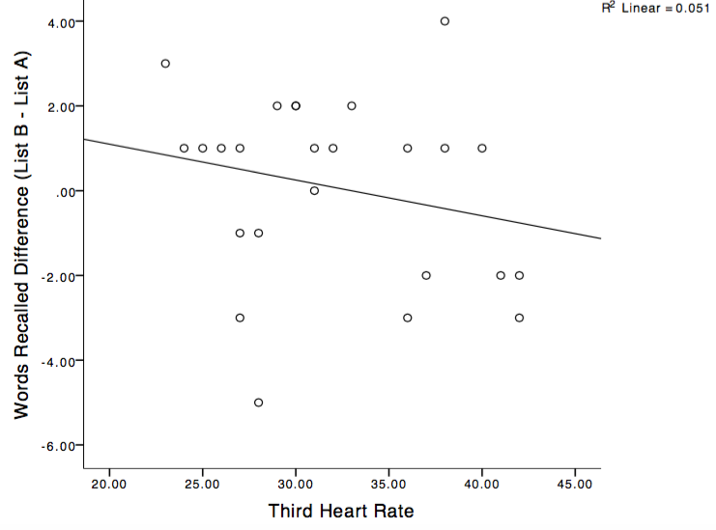

Figure 1. Words recalled difference as a function of all participants’ third heart rates.

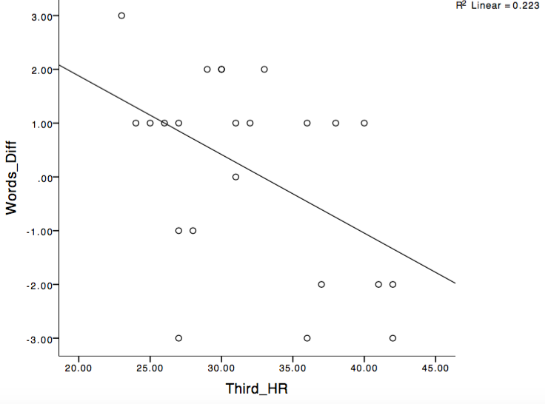
Figure 2. Words recalled difference as a function of participants’ third heart rates with outliers removed.

